W47: Visualize global development or historical homicides

**DESCRIPTION**

For this Visualisation assignment, you engage in two tasks and submit an rmarkdown document with a knitted result that collects the results of both tasks:

**A: same for everyone: Visualize the duration of reign among Danish kings through time (from ca 900 - today) with ggplot. Use the dataset you/your group has created and submit both the script and the visualisation, ideally as part of an rmarkdown and html document (for details see bottom of this page).**

* First I have to create a new row called “Length_of_reign” to make a visualization over the length of the Danish monarchs
* But then I realized that R was reading the Start_of_reign and the End_of_reign columns as characters, so I needed to mutate them into numbers.
* That’s what I did on line 15 and 16
* And then it was time to calculate the Start_of_reign and the End_of_reign
* I created a new column called “Length_of_reign” and the “=” sign made R calculate the Start_of_reign minus End_of_reign.
* To make a new dataset I used the “->” function and called it Kings_clean

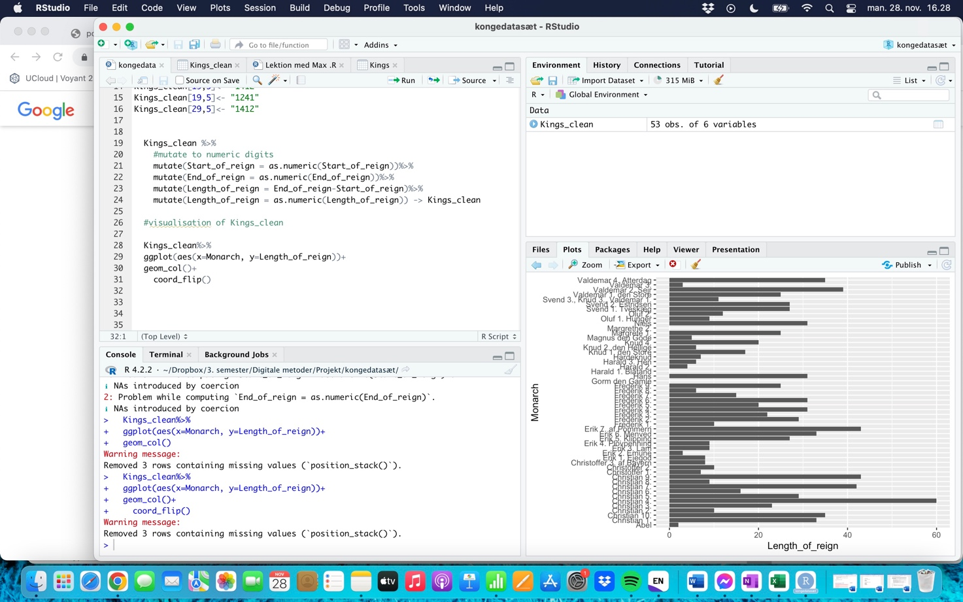

**B:** choose **one** of the two options below and follow the instructions in rmarkdowns. These have slightly different content depending on what you wish to practice, whether facets in ggplot or animation. For the latter, pay attention to the prerequisites R specifies for your system:

1. Historical homicide trends across Western Europe (ggplot practice) <https://github.com/Digital-Methods-HASS/HomicideHistory>

<file:///Users/annatarp/Desktop/HomicideHistory-main/EuropeanHomicide_exercise.html>

OR

2) Global development since 1957 (learn how to create animations with *gganimate* package! :) <https://github.com/Digital-Methods-HASS/GlobalDevelopment>

How to complete this assignment: I am asking you to work with assignments from Github and submit answers to Github. You can do so manually following step in Manual guide, or on the command-line(CLI)

Manual guide:

1. Download the homework repository
2. Look at the .html file to see the tasks
3. Edit the .Rmd file to complete the tasks (ie. create additional code chunks and comments in the text sections) and then press the Knit button to render the results as a new .html file the same way you did in Week 01 UN Votes exercise
4. Upload these via 'Upload File' button to your au##### folder in Digital-Methods-HASS organization.

CLI guide (only if you use command-line):

1. clone **your**au##### repository from Github Digital Methods HASS so you have it available locally
2. **clone**one of the homework repositories next to your your **local**au##### folder
3. complete the tasks and knit the result
4. once happy with the result, **copy**the finished .Rmd and .html files from the HomicideHistory/GlobalDevelopment folder into your**local** au##### folder
5. **add**and **commit**the changes in your au##### folder
6. **push**the knitted result to **your au#####**repository in Github

Submit here a to **your** **au#####** repository in https://github.com/Digital-Methods-HASS ... which leads directly to the place where you have posted your solution as **both** **.Rmd** and **.html** files.

*Note: if you are unsure that you uploaded the .html to Github correctly, use https://htmlpreview.github.io/ to preview it!*